CSE 2221: systemS programming

How to Create a C Program in Linux

Introduction

This manual is designed for the Penn State students who are in the Computer Science and Computer Engineering Major, have finished C++ language programming and ready to take the class CMPSC 311 Operating System Programming in C language. Students who have not yet had any programming experience in Linux system, to learn a new system and terminal commands might take up to ten hours to get used the new programming environment. The purpose of this manual is to decrease this spending time for students and expected time to create a simple C program in 20 minutes.

Terms

- Linux: A Computer operating system was named for Linux kennel, written 1991 by Linux Torvalds of Finland.
- Terminal: An electronic or electromechanical device for entering data into a computer or communications system and displaying data received.
- Command Line: Commands that a user types in order to run an application.
- Header File: A file contains C declarations and Marco definitions to share between several source files.
- Current Directory: the directory of a hierarchical file system where user is working on.

Overview

There are total 5 steps to accomplish a C program in Linux.
- How to Log in User’s Account page 2
- How to Open a Terminal and Run Command Page 2
- How to Create a C Program Page 4
- How to Compile a C Program Page 6
- How to Run a C Program Page 8

Step A: How to Log in User’s Account

- Username: Your regular Penn State email ID. (e.g. xyz1234)

- Password: Your password for this computer machine would be different from your regular password in Penn State.
  - If this is your first time to log in, your password will be your nine digit student ID numbers and followed by your name initial in lowercase and uppercase.
(e.g. 987654321abcABC)
  - If your password is not working, you might want to contact the administration office at CL1 on the first floor. Otherwise, if you have your password, please continue this process.

Step B: How to Open a Terminal and Run Command

- Right click the mouse, you will see the option Open in Terminal, then click on it. The terminal will be opened.
- Type the command pwd to display where your current working directory is.
Note: The current directory displays in the green circle.
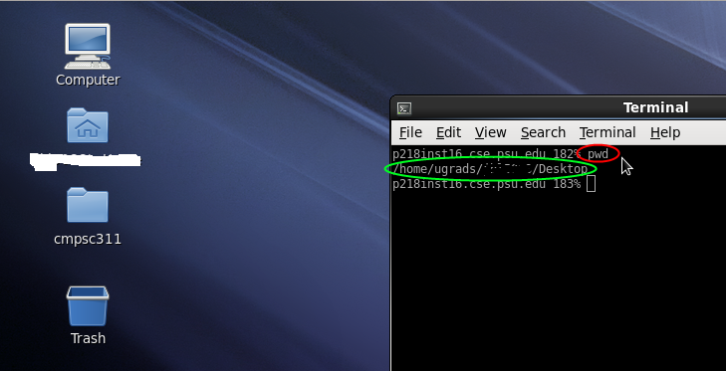

- Type command mkdir to make a new directory/fold to contain your source code.
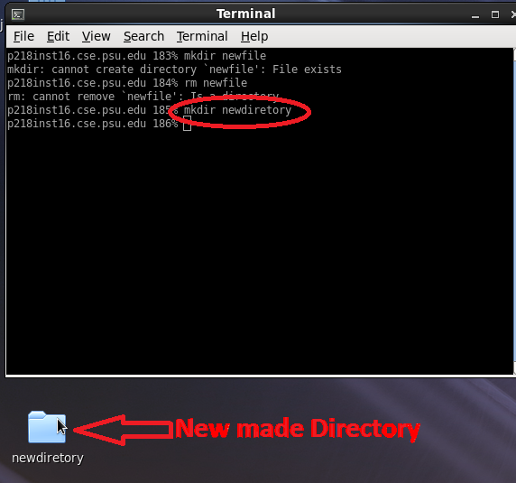

Step C: How to Create a C Program

- Type gedit in the command line.
Note: It will open a text file that let you create your source code.
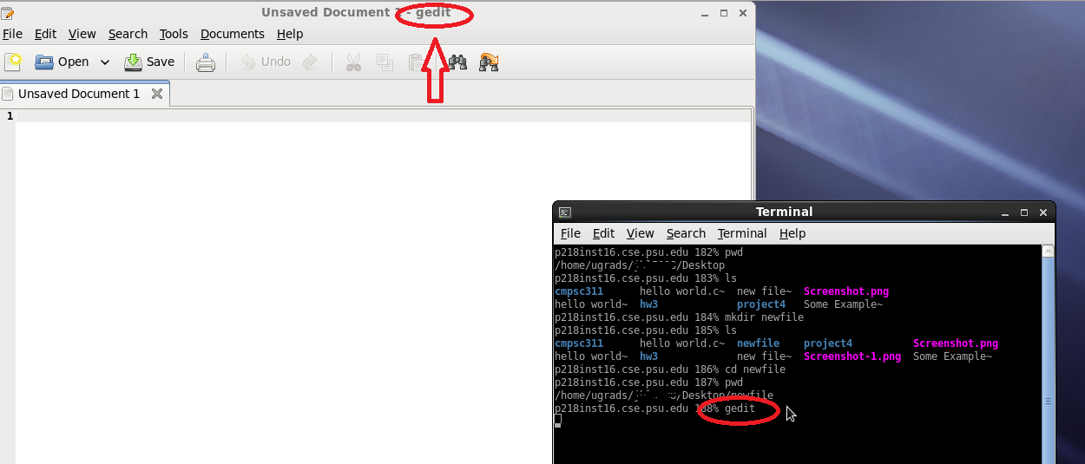

- Type includes <stdio.h> to include the header file for your input and output stream at the beginning of program.
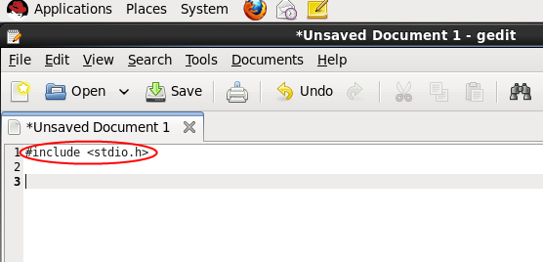
    - Warning: Even though C and C++ languages have similar name. But cout only works for C++, not for C language,
- Test the output of your string message.
    - Troubleshooting: Type printf(“ input your text message here”); inside the block of main function, it will output a string in C language.
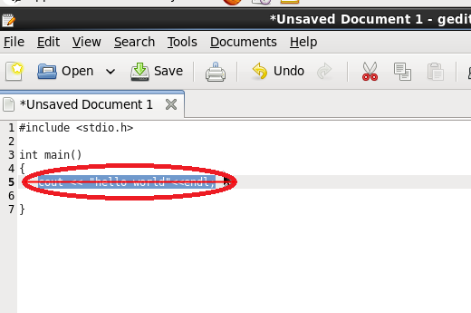
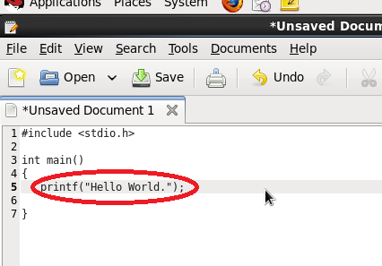

- Save your c file (eg. helloworld.c ) to the convenience place where you are free to access to and then you can move to next step.
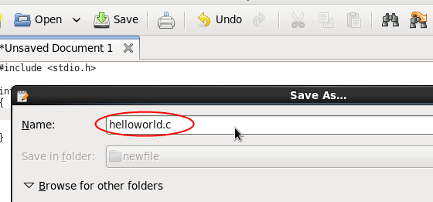

Step D: How to Compile a C Program

- Type gcc -o output_filename source_code to compile your source code.
Note:
  - Linux has so many different compilers for compiling different programs. First let's check for the example of gcc compiler which is invented by GNU.
  - Hyphen O is indicating your output file option. So the compiler knows what the filename you want to give your program.
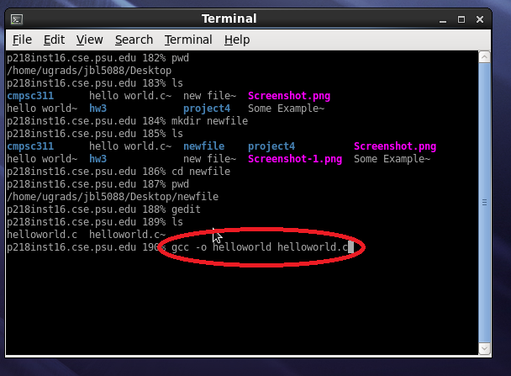

- Type ls for list all file name in the current directory which you can check that the executive program is ready to run. Every executable file is labeled in color green.
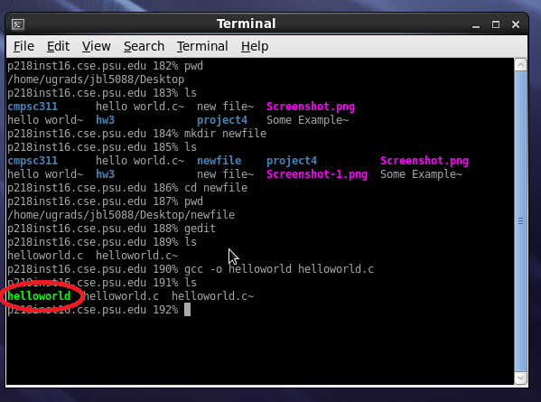

Step E: How to Run a C Program

- Type ./helloworld in the command line to run your program.
Note: Type ./ (dot and slash) to refer the current directory. And Make sure your program name followed after the current directory.
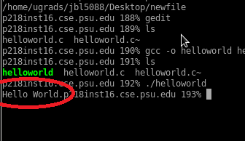

- Check the output if it is what you expected, if the output is not what you expected, please repeat Step 1 – 4.
- Congratulation. Your Program is completely done.

